React-app-Submission-Screenshot

1. GitHub Link : <https://github.com/prasanth-wizard/Trend.git>

**Git Repository:**

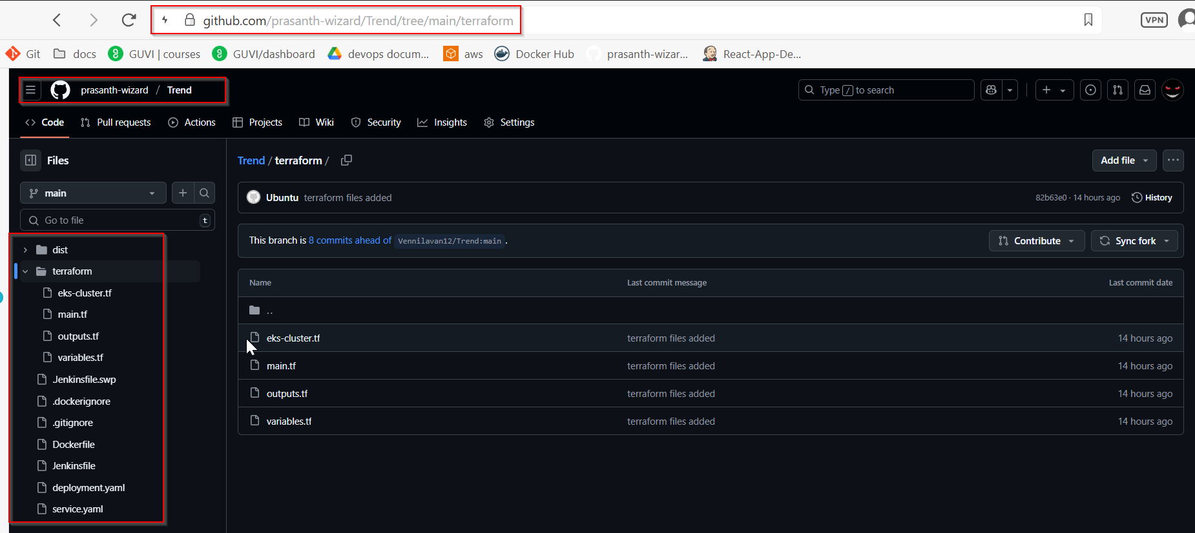

1. **Documented screenshots link:**

https://drive.google.com/drive/folders/1FyhLe524vI2vGqFkB5Mp-IL_P2rhgDlG

1. **Application deployed kubernetes Loadbalancer ARN:**

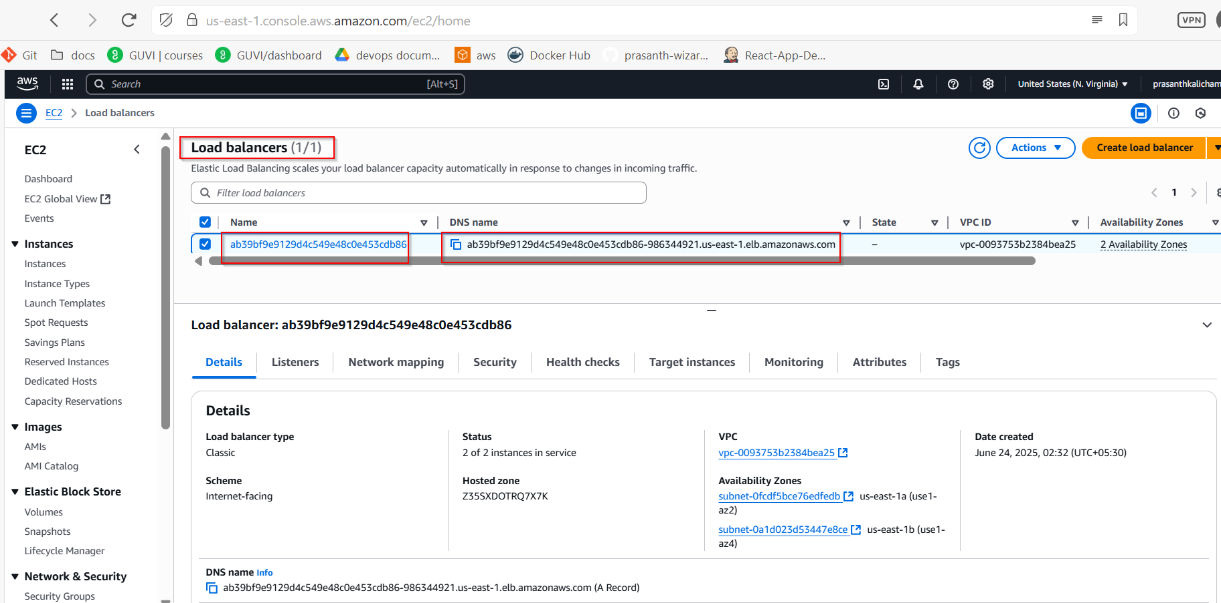

DNS: ab39bf9e9129d4c549e48c0e453cdb86-986344921.us-east-1.elb.amazonaws.com